Jill Botvinik: member of OCMGA since 2011.

Running for the office of Vice President

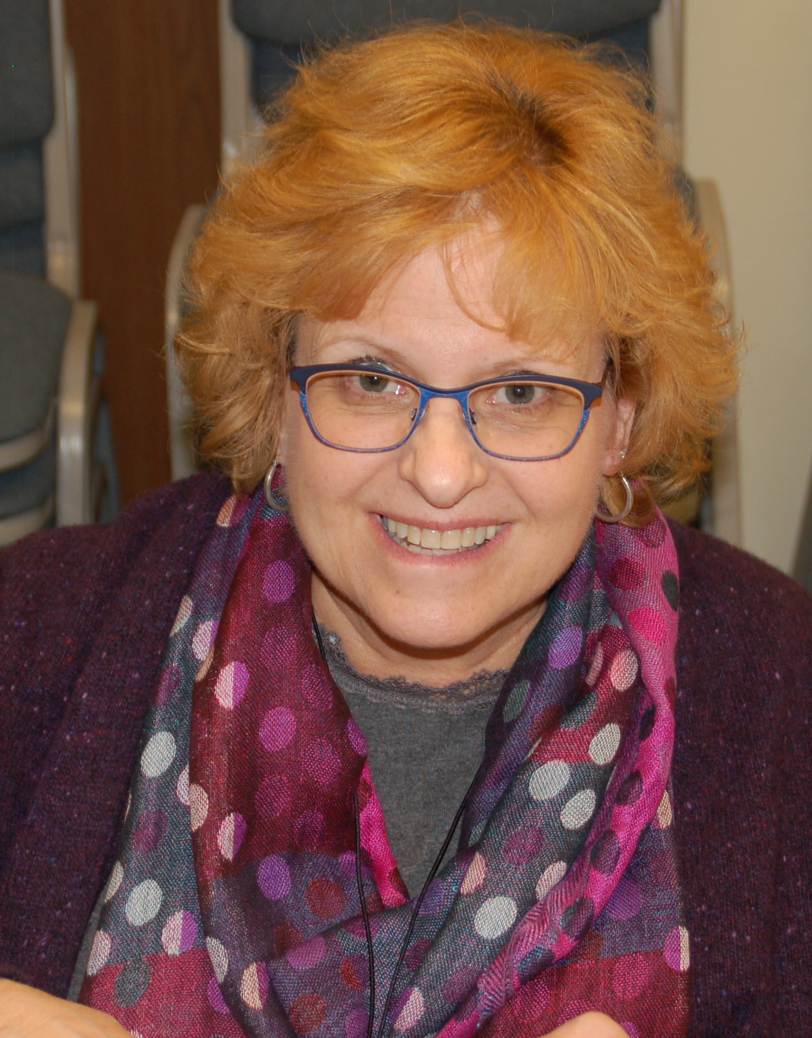

Nancy Goodman: member of the class of 2018

Running for the office of Executive Secretary

Jackie Draws: member of OCMGA since 2017

Running for the office of Treasurer.

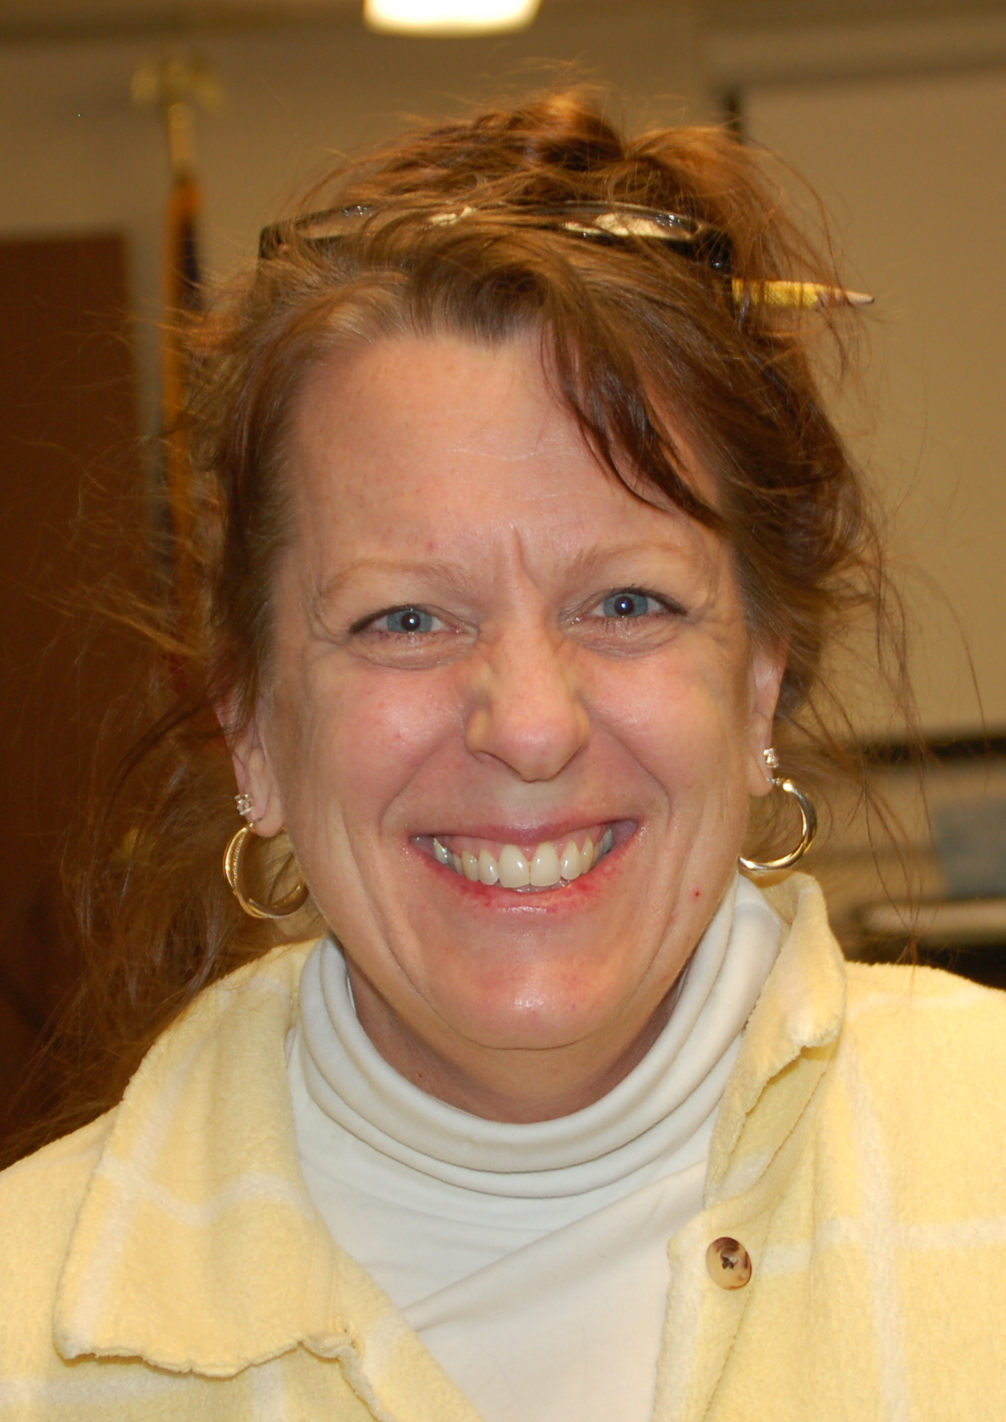
Donna Nett-Haus: member of the class of 2018

Running for the office of Member-at-Large

